**Lab 4 Report**

**Lab Exercise**

**1. Introduction&Objective**

The main objective of this experiment is to implement the non-deadbeat output feedback control system, designed in Experiment 3, onto the actual water tank system (W-T) and evaluate its performance. Due to changes in the experimental setup (such as valve positions and system characteristics), it is necessary to repeat the system identification process and adjust the previously designed control algorithm for the new system model, ensuring that the system operates stably and meets the performance requirements.

1. **Process**
   1. System Identification

Repeat Lab2 and here is the new data of the W-T system.

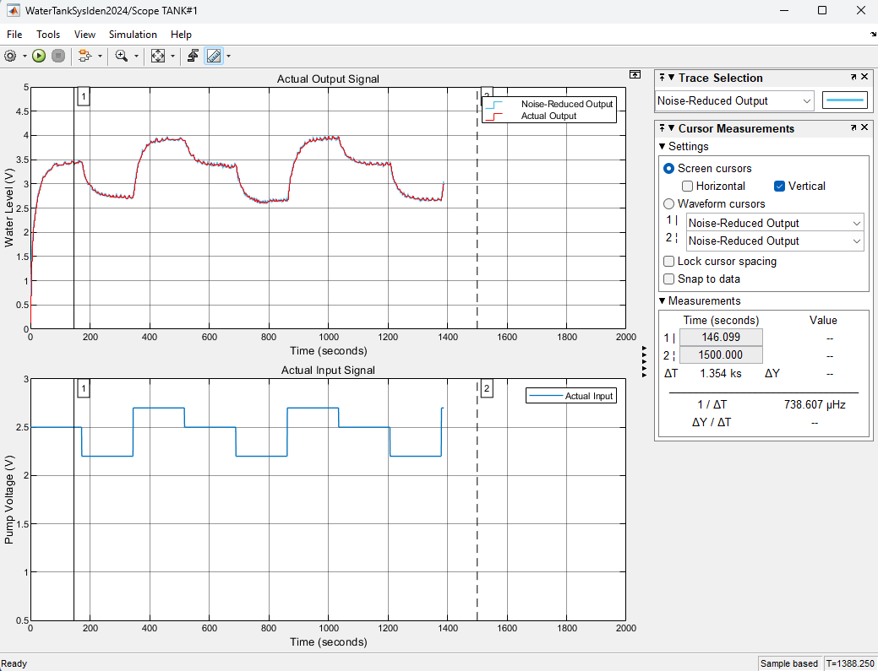

Figure 1. Collection Data

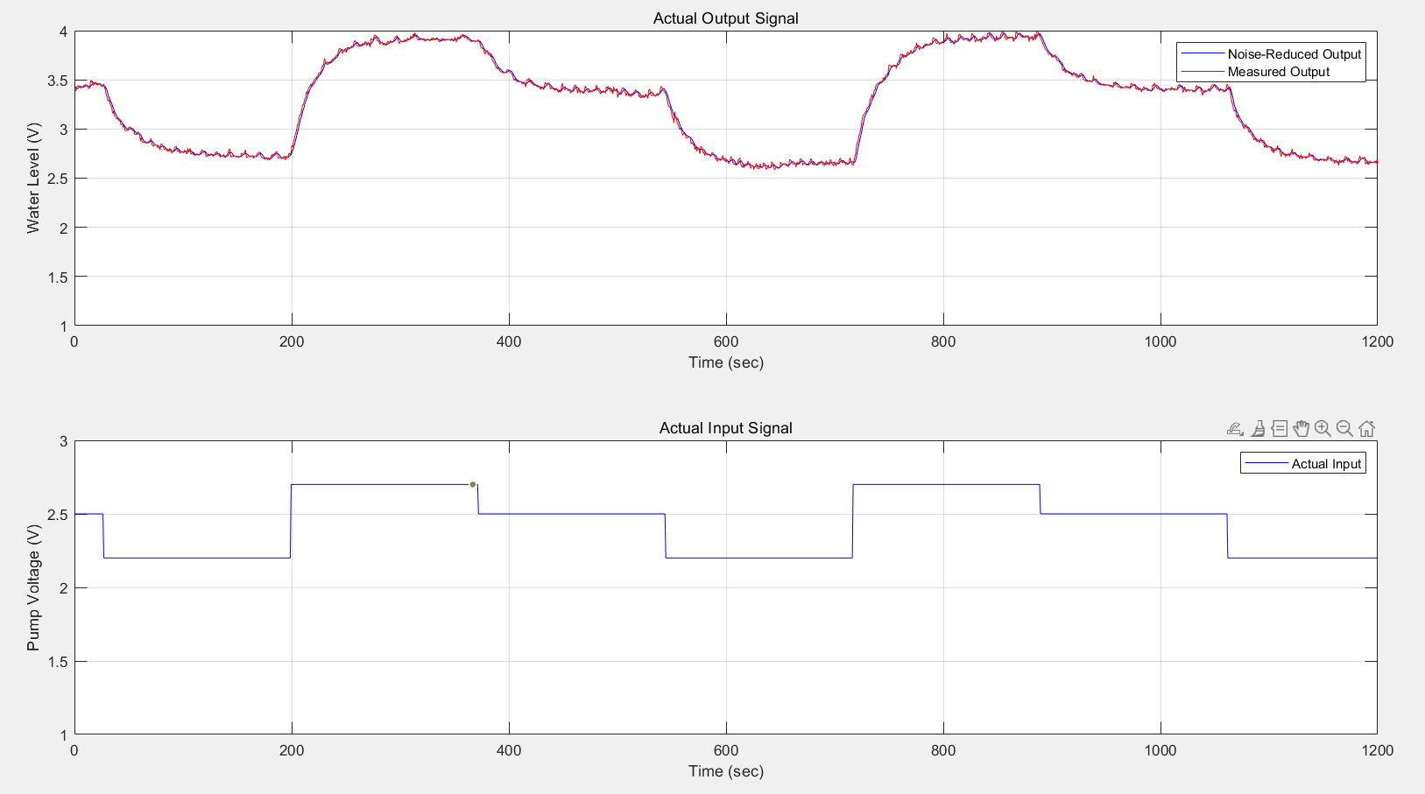

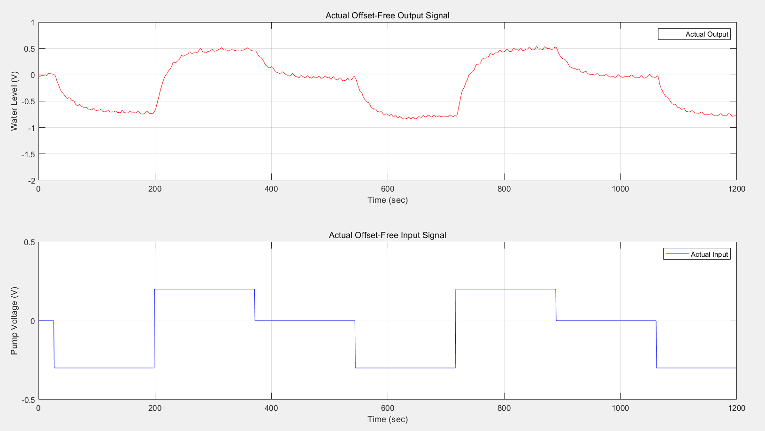

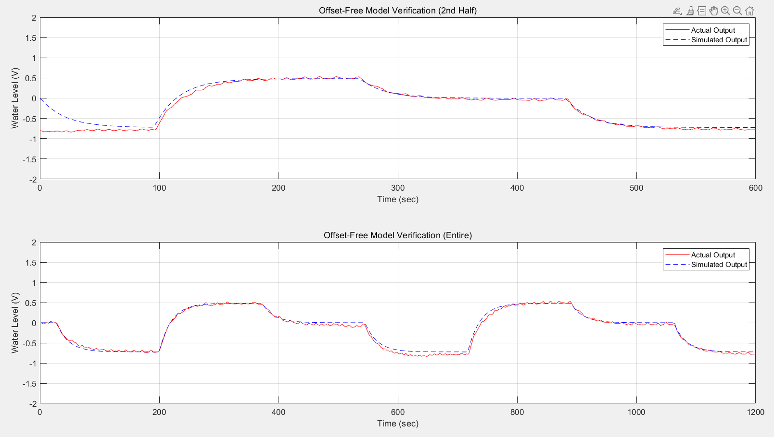

Figure 2. Results repeat Lab 2

* 1. Output Feedback Control Design

Then repeat the Lab 3, the goal of the control system is to track the reference signal y{k} = {0,0.7,−0.2,0.5,0} as quickly as possible, with each level period being 140×0.75=105s.

These parameters are specified in the MATLAB workspace for the Simulink model.

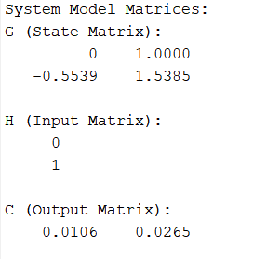 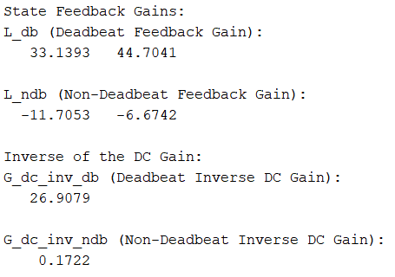

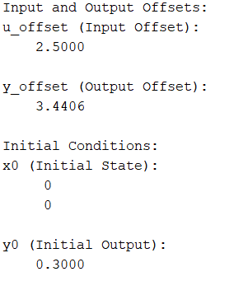

From the figure, it can be observed that the simulated output tracks the reference voltage well, and the simulated control input is also kept within the ±0.5V voltage threshold range.

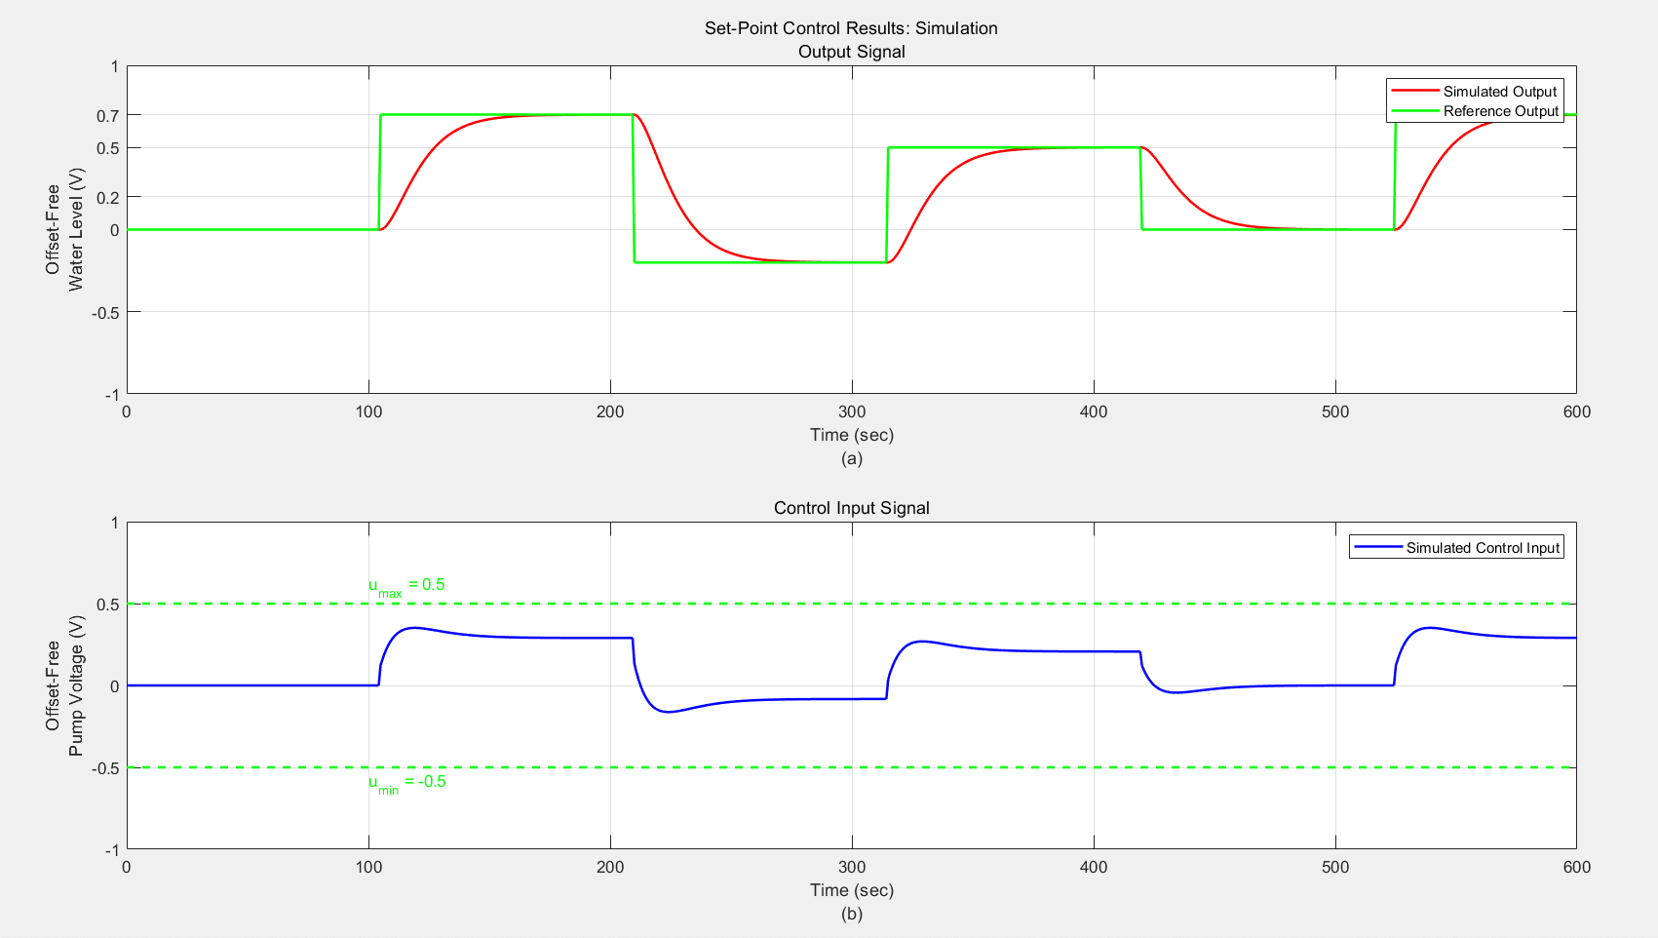

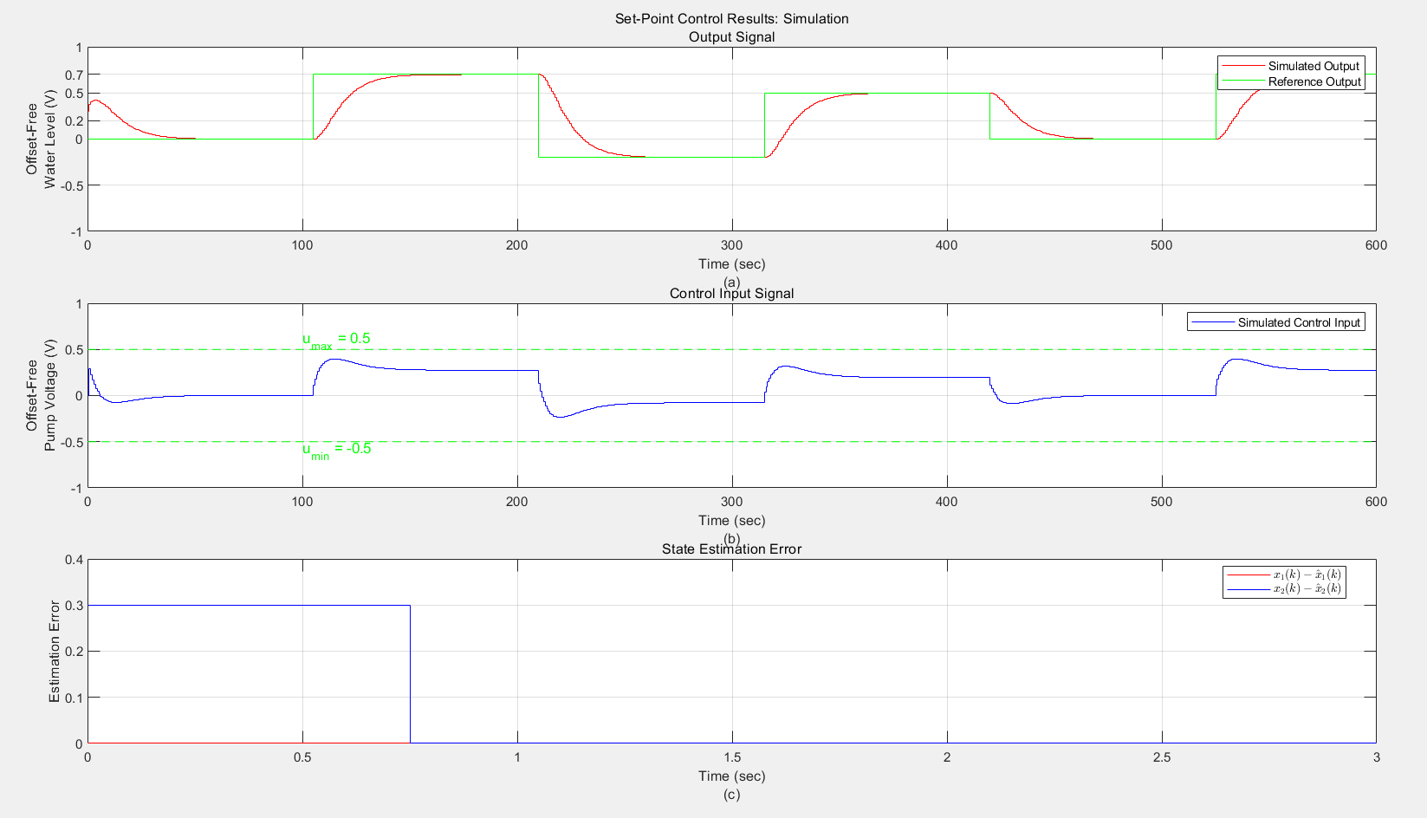

Figure 3. Results repeat Lab 3

* 1. Real-time implementation of the control system

After the real-time implementation of the control system is completed, the next step is to extract data from both the simulation and the actual experiment, and perform a detailed comparison of the results.

These graphs show the time-varying output feedback control results and control input

signals. The actual output (red) tracks the reference output (green), indicating that the control system is running as expected. However, the actual control input experienced a brief overshoot at the front end of the water tank startup, exceeding the set voltage threshold.

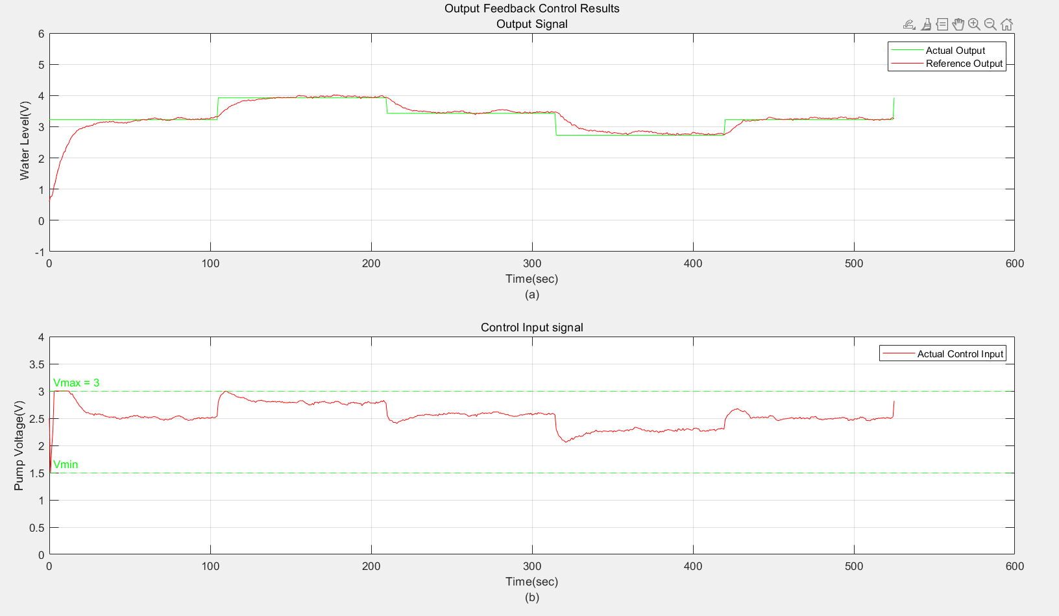

Figure 4. . Comparison between simulated and actual output feedback control

Optional as Bonus: Because a high voltage is initially required to drive the water tank, there will be a clipping effect exceeding the voltage threshold at the beginning of the input stage. If high voltage is undesirable, a certain amount of water can be pre-stored in the tank.

**Conclusion**

The main objective of this experiment is to implement the non-deadbeat output feedback control system onto the actual water tank system and evaluate its performance. Using the water tank model in the experiment, system identification was first performed to obtain a new system model, and based on this, the output feedback control system was designed.